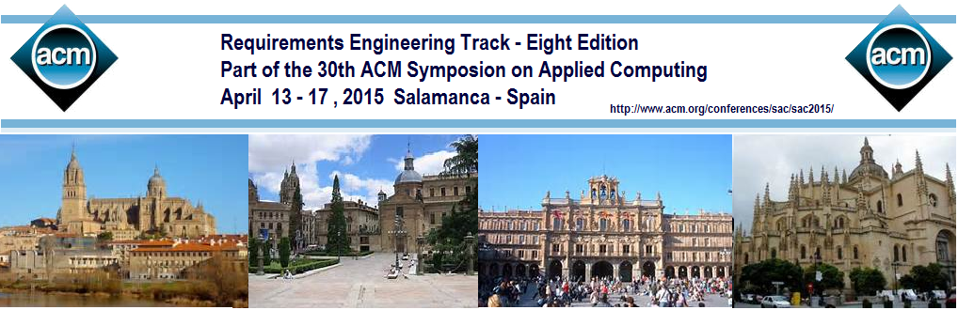
 | For the past twenty-nine years, the ACM Symposium on Applied Computing (SAC) has been a primary gathering forum for applied computer scientists, computer engineers, software engineers, and application developers from around the world. The Eight Edition of the Requirements Engineering Track (RE-Track'15) is part of the 30th ACM Symposium on Applied Computing. SAC 2015 is hosted by University of Salamanca. Further details may be found at: http://sac2015.ecomp.poli.br/. The objective of this track is to explore different advances in requirement engineering in a general way, its relation with different areas, reducing the gap between software engineering solutions and the way one specific domain of knowledge was seen up to given point.  TOPICS  Topics of interest include, but are not limited to, the following:  - Automatic software generation  - Requirements Engineering for Scientific Areas  - Requirements elicitation, analysis, documentation  - Requirements specification languages, methods, processes, and tools  - Requirements management, traceability, viewpoints  - Modeling of requirements, goals, and domains  - Non-functional requirements  - Requirements engineering and software architecture  - Aspect-oriented requirements engineering  - Agent-oriented requirements engineering  - Requirements for COTS-based systems  - Case studies and experiences based on requirements engineering  - Social, cultural, and cognitive factors in requirements engineering  - Requirements engineering: education and Training  - Requirements and Simulation  - Requirements and Autonomic Systems  - Requirements Reuse  TRACK CO-CHAIRS  Maria Lencastre (mlpm@ecomp.poli.br)  Universidade de Pernambuco, Brazil  João Araújo (p191@fct.unl.pt)  Universidade Nova de Lisboa, Portugal | IMPORTANT DATES  Paper submission: Sept. 12, 2014 Oct. 10, 2014  Authors Notification: Nov.17, 2014  Camera-Ready: Dec. 8, 2014  PAPER SUBMISSION  Authors are invited to submit in all areas of Requirement Engineering. The program committee will blindly review submissions to that track. The author(s) name(s) and address(es) must not appear in the body of the  paper, and self-reference should be in the third person. This is to facilitate blind review. The paper should not exceed 6 pages in ACM format.  Please note that the maximum page length for the conference is 6 pages (without extra-fee), 8 is the maximum (with extra-fee). Submissions should be printable on a standard printer on common paper formats, such as US letter and A4. Papers should not be submitted to more than one ACM-SAC track. Paper submissions should be done electronically through the website at http://www.acm.org/conferences/ sac/sac2015/.  STUDENTS COMPETITION  Active graduate students seeking feedback from the scientific community on their research ideas are invited to submit abstracts of their original unpublished and in-progress research work in areas of experimental computing and application development related to SAC 2015 Tracks. Please visit SAC 2015 website.  Paper registration is required for inclusion of the paper in the conference proceedings. An author or a proxy attending SAC MUST present the paper. This is a requirement for the paper to be included in the ACM/IEEE digital library. No-show of registered papers will result in excluding them from the ACM/IEEE digital library
 | PROGRAM COMMITTEE
- Alberto Silva, Instituto Superior Técnico, Lisboa, Portugal
- Ana Moreira, Universidade Nova de Lisboa, Portugal
- Carme Quer, Universitat Politècnica de Catalunya, Barcelona, Spain
- Camille Salinesi, Université Paris 1 Panthéon - Sorbonne, France
- Carla Silva, Universidade Federal de Pernambuco, Brazil
- Daniel M. Berry, University of Waterloo, Canada
- E. A. Schmitz, Federal University of Rio de Janeiro, Brazil
- Emilio Insfran, Universitat Politècnica de València, Spain
- Giancarlo Guizzardi, Federal University of Espirito Santo, Brazil
- Guilherme Horta Travassos, COPPE/UFRJ, Brazil
- Gunter Mussbacher, McGill University, Canada
- Guttorm Sindre, IDI/NTNU, Norway
- Gustavo Rossi, Universidad Nacional de La Plata, Argentina
- Hermann Kaindl, Vienna University of Technology, ICT, Austria
- Hernán Astudillo, U. Técnica Frederico Santa María, Chile
- João Araújo, Universidade Nova de Lisboa, Portugal
- João Pascoal Faria, FEUP, Portugal
- Juan Pablo Carvallo, Universidad del Azuay, Cuenca, Equador
- Julio Leite, PUC-Rio, Brazil
- John Mylopoulos, University of Toronto, Canada
- Joost Noppen, University of East Anglia, UK
- Kamel Rouibah, Kuwait University, Kuwait
- Lawrence Chung, University of Texas, Dallas
- Maria Lencastre, Pernambuco State University, Brazil
- Maritta Heisel, Duisburg-Essen University, Germany
- Mauricio Alferez, INRIA, France
- Orlena (Olly) Gotel, Independent Researcher, USA
- Oscar Pastor, Universitat Politècnica de València, Spain
- Pete Sawyer, Lancaster University, UK
- Uirá Kulesza, Federal University of Rio Grande do Norte, Brazil
- Rosangela A. Dellosso Penteado, Federal University os São Carlos, Brazil
- Seok-Won Lee, Ajou University, Republic of Korea

